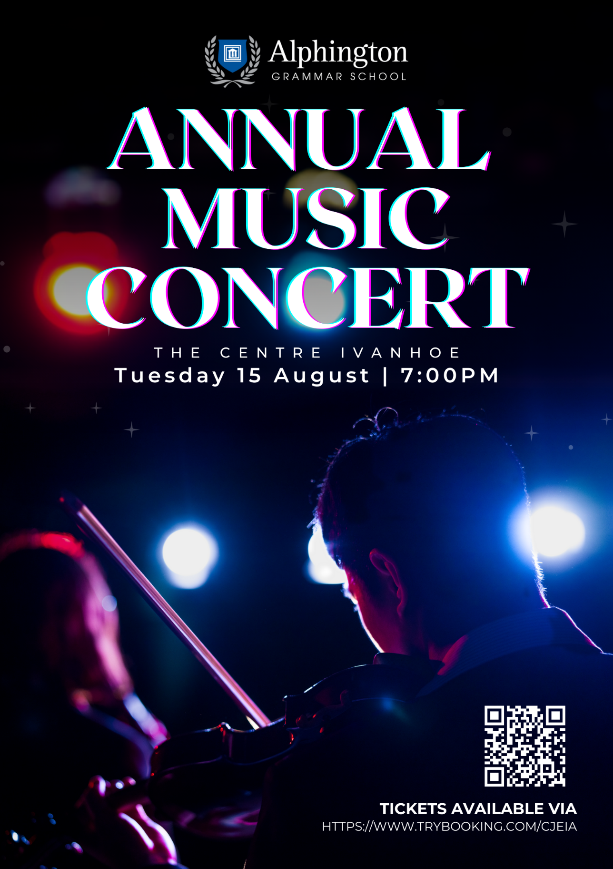

Tickets on sale Friday 23 June at 9AM.

